LAPORAN PRAKTIKUM PBO

Inheritance, Absrtact and Interface

Disusun oleh :

Muhamad Rafli Nur Ikhsan

201511048

D-3 Teknik Informatika 2B

Jurusan Teknik Komputer dan Informatika

Program studi D3 Teknik Informatika

Politeknik Negeri Bandung

1. Task 1

SS akhir program

* 1.1 Modify class Circle, add :

1. variable color : string

1. Constructor Circle(radius : double, color : string)

1. Getter and setter for color

* 1.2 :

1. Try overriding the getArea() method in the subclass Cylinder to compute the surface area (=2π×radius×height + 2×base-area) of the cylinder instead of base area.

1. Fix the getVolume()

* 1.3 :

2. Task 2

SS akhir program

* The Shape class contains
* Two instance variables color (String) and filled (boolean).

* Two constructors: a no-arg (no-argument) constructor that initializes the color to "green"and filled to true, and a constructor that initializes the color and filled to the given values.

* Getter and setter for all the instance variables. By convention, the getter for a boolean variable xxx is called isXXX() (instead of getXxx() for all the other types).

* A toString() method that returns "A Shape with color of xxx and filled/Not filled".

* The Circle class contains
* An instance variable radius (double).



* Three constructors as shown. The no-arg constructor initializes the radius to 1.0.

* Getter and setter for the instance variable radius.

* Methods getArea() and getPerimeter().

* Override the toString() method inherited, to return "A Circle with radius=xxx, which is a subclass of yyy", where yyy is the output of the toString() method from the superclass.



* The Rectangle class contains
* Two instance variables width (double) and length (double).

* Three constructors as shown. The no-arg constructor initializes the width and length to 1.0.

* Getter and setter for all the instance variables.

* Methods getArea() and getPerimeter().

* Override the toString() method inherited, to return "A Rectangle with width=xxx and length=zzz, which is a subclass of yyy", where yyy is the output of the toString() method from the superclass.

* The Square class contains
* Provide the appropriate constructors (as shown in the class diagram).

* Override the toString() method to return "A Square with side=xxx, which is a subclass of yyy", where yyy is the output of the toString() method from the superclass.

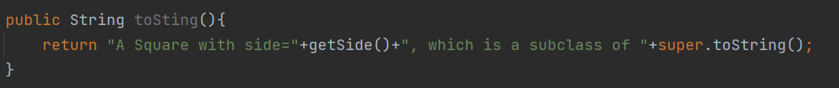

* Do you need to override the getArea() and getPerimeter()? Try them out.

* Override the setLength() and setWidth() to change both the width and length, so as to maintain the square geometry.

